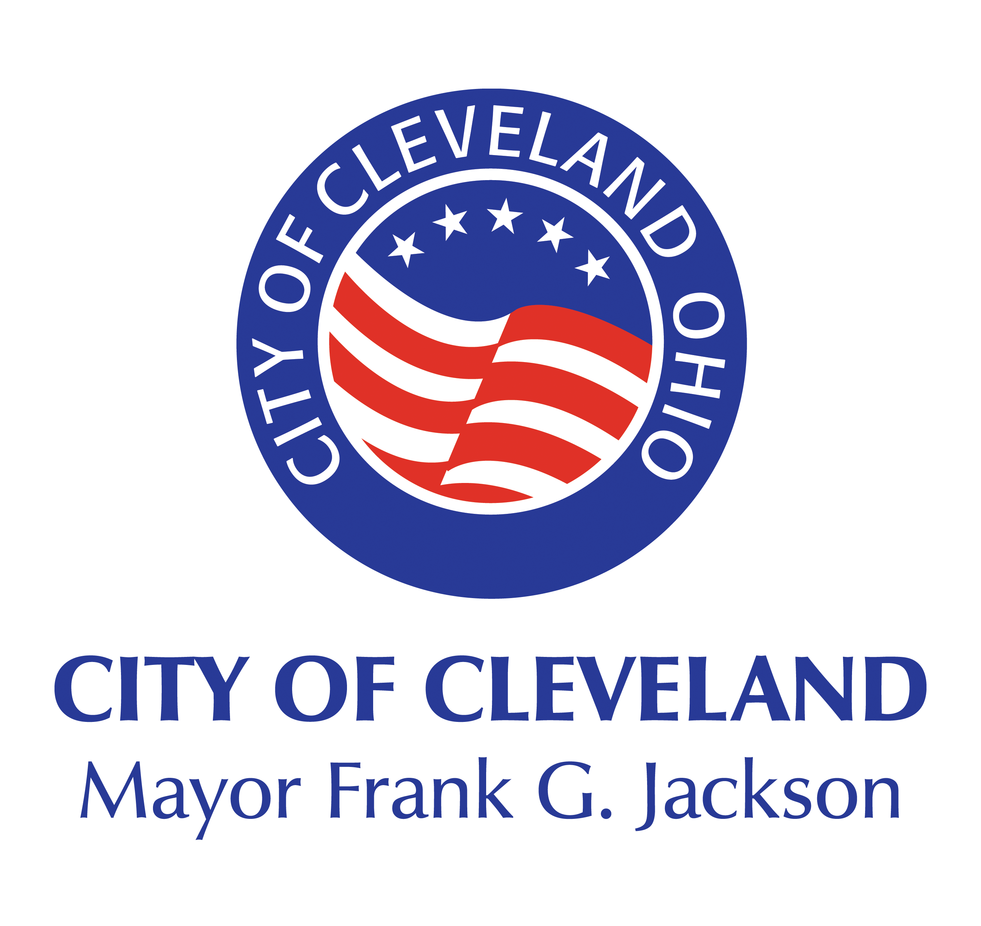
CITY OF CLEVELAND

DEPARTMENT OF ECONOMIC DEVELOPMENT

SAFE OPERATIONS SUPPORT GRANT APPLICATION

The City of Cleveland has allocated $500,000 to provide grants of up to $10,000 to help support our small businesses invest in personal protective equipment (“PPE”) and materials to protect employees operate outdoor their business including outdoor spaces throughout the winter of 2020-21 during the COVID-19 pandemic.

The City will accept applications as funds are available. Funds expended after March 1, 2020 are eligible for reimbursement under the grant.

A. APPLICANT IDENTIFICATION: DATE:

1. Legal Name of Business:

- Common Name of Business (if applicable):

- Address of Business: (Operating)

- Ward: Councilperson:

- Phone Number: Tax Payers ID Number:

6. Business Owner(s):

7. E-Mail Address:

- Mailing Address: (If Different from Operating Address)

- When Business Opened: ______________________________________________________

B. FUNDING REQUEST:

- Amount of Funding requested (Up to $5,000):

- The grant funds purchase or rental of equipment and fixtures (heaters, temporary “igloo” structures, awnings etc.) necessary to operate with outdoor access through the winter. Please detail anticipated uses of funds:

C. STATEMENT OF NEED:

Please provide the following information about your planned operations:

- My Business has access to an outdoor patio as part of our normal operations
- My Business has access to an outdoor public space, sidewalk, right-of-way, or other such space, or to an outdoor private space (i.e. parking lot, greenspace) that has agreed to allow my operations.
- My Business does not have access to an outdoor space but plans to operate with substantial outdoor “wall-less” access (open windows, “garage doors” or similar accommodation) that will increase ventilation throughout the restaurant.

Please provide a brief statement describing your operational plans: _______________________
______________________________________________________________________________________

______________________________________________________________________________________

D. BUSINESS PROFILE:

- Number of employees as of March 1, 2020 (Pre-COVID) _______

- Number of employees as of the date of application: ______

- Eligible Small Business Verification (Please check one):

_____ Applicant is not a nationally-owned chain operation.

_____ If Applicant is a franchise, principal owners of franchise are residents of the State of Ohio

_____ If Applicant is a franchise, principal owners of franchise are residents of the City of Cleveland

_____ Applicant is a business with not more than 500 employees.

_____ Applicant is an individual who operates under a sole proprietorship, with or without employees, or as an independent contractor.

_____ Applicant is a cooperative with not more than 500 employees.

_____ Applicant is an Employee Stock Ownership Plan (ESOP), as defined in 15 U.S.C. 632, with not more than 500 employees.

_____ Applicant is a tribal small business concern, as described in 15 U.S.C. 657a(b)(2)(C), with not more than 500 employees.

_____ Applicant is a business, including an agricultural cooperative, aquaculture enterprise, nursery, or producer cooperative, that is small under SBA Size Standards found at https://www.sba.gov/size-standards.

_____ Applicant is a business with more than 500 employees that is small under SBA Size Standards found at https://www.sba.gov/size-standards.

- Eligible Business Activity/Certifications (All must be checked):

_____ Applicant is not engaged in any illegal activity (as defined by Federal, State, or Local law and regulations).

_____ No principal of the Applicant with a 50 percent or greater ownership interest is more than sixty (60) days delinquent on child support obligations.

_____ Applicant, and any affiliates, are no more than sixty (60) days delinquent on any Federal, State, or Local tax payments, unemployment insurance payments, worker’s compensation payments or similar required payments.

_____ Applicant, and any affiliates, are no more than sixty (60) days delinquent on any payments on any loans received from the City of Cleveland, as of March 1, 2020.

_____ Applicant is not an agricultural enterprise (e.g., farm), other than an aquaculture enterprise, agricultural cooperative, or nursery.

_____ Applicant does not present live performances of a prurient sexual nature or derive directly or indirectly more than de minimis gross revenue through the sale of products or services, or the presentation of any depictions or displays, of a prurient sexual nature.

_____ Applicant does not derive more than one-third of gross annual revenue from legal gambling activities.

_____ Applicant is not in the business of lobbying.

_____ Applicant, and any owners thereof, are not employed by the City of Cleveland. Applicants who are contractors to the City of Cleveland are eligible.

E. LOAN CHECKLIST:
The following items must be submitted prior to closing. They do not need to be submitted with the application. The Department of Economic Development will outreach directly for this information.

Corporate Documentation:
Articles of Incorporation (if applicable)
Partnership Agreement (if applicable)
Certificate of Good Standing (Ohio Secretary of State)
Previous Year Financial Statements
2018 or 2019 Tax Return.
Copy of Lease (if leasing property)

SUBMISSION OF ACKNOWLEDGEMENT
The information contained herein is true, complete and correct to the best of my knowledge. I certify that I have the authority to apply for funds on behalf of the business described herein. I understand that this information may be made for public review. By signing below, the undersigned agrees that the funds will be used for business purposes only and not for household, personal or consumer usage. I understand that any false statement in this record may subject the applicant to be eliminated from consideration. I authorize the City of Cleveland and its staff to obtain any necessary information, including tax records, credit scores, or other financial information, relevant to the loan application and review process.

I understand that all information obtained by the City will remain confidential pursuant to the applicable local, state, and federal laws.

Applicant Name

By:
Officer of Corporation or Partner of Corporation Date

OR

By:
Individual Date

NOTE: The City shall consider all information provided by applicant to be public record absent clear evidence that the information submitted is not to be released, pursuant to Ohio Revised Code Section 149.43.

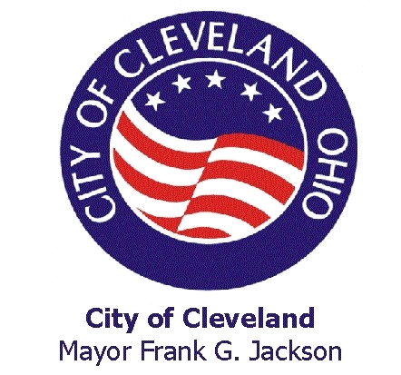
City of Cleveland

Fair Employment Law

NOTICE TO APPLICANTS FOR CITY FINANCIAL ASSISTANCE. The Cleveland City Council passed the Fair Employment Law on June 19, 2000 to be effective on January 1, 2001.

A financial assistance contract that may be awarded pursuant to this application is subject to the City of Cleveland Fair Employment Wage, Chapter 189 of the Cleveland Codified Ordinances (C.C.0), which requires, among other things, that unless specific exemptions apply, Covered Employers, as defined, under contracts with the City shall pay the Fair Employment Wage to Covered Employees, as defined. Failure to comply with that Chapter and/or any implementing regulations may result in termination of the contract or debarment from future contracts.

Attachments: Attachment 1 Declaration of Number of Employees
Attachment 2 Declaration of Health Insurance Coverage
Attachment 3 Affidavit of Compliance with C.O. Chapter 189
Attachment 4 Current Assistance Contracts
Attachment 1-3 will be provided to City Council

Fair Employment Wage: The Fair Employment Wage is $10.00 per hour beginning October 1, 2005. Thereafter, the Fair Employment Wage rate will be adjusted by the City of Cleveland each year in proportion to the Consumer Price Index for Northeast Ohio, as published by the Bureau of Labor Statistics, U. S. Department of Labor.

The Fair Employment Law applies to the following Covered Employers:
- Any person or entity that is a Recipient of Assistance from the City that has an Aggregate Value of $75,000 and has not been granted an exemption from this law, that is either:

- A for-profit employer having at least 20 employees at the time of execution of agreement with the City, or
- A not-for-profit employer having at least 50 employees at the time of execution of agreement with the City and the salary ratio between the highest paid and the lowest paid employees is more than 5 to 1.

OR

- A company or person that is a tenant or leaseholder of a Recipient of Assistance and that occupies property or uses equipment or property that is improved or developed as a result of assistance, that is either:

- A for-profit employer having at least 20 employees at the time of execution of agreement with the City, or
- A not-for-profit employer having at least 50 employees at the time of execution of agreement with the City and the salary ratio between the highest paid and the lowest paid employees is more than 5 to 1.

OR

- A contractor or subcontractor of a Recipient of Assistance providing service in the project or matter for which the Recipient of Assistance has received assistance.

Recipient of Assistance means any person or entity that enters into one or more contracts with the City for Assistance and any person or entity that is a direct recipient of Assistance. Assistance means any form of City assistance that is awarded, renegotiated or renewed after January 1, 2001.
- Assistance includes grants; economic development loans; tax credit, incentives and abatements; subsidiaries and bonds.
- Assistance does not include financial assistance provided for the development, rehabilitation or other means of providing residential homes; financial assistance which is received from another government or other entity with the City acting only as a conduit or fiscal agent for the funds where the City exercises no control over the identify of any recipient or of the terms of the contract.
- Assistance is valued to the extent that the recipient derives a monetary benefit from the City. For example, loans are Assistance only to the extent they are forgiven or discounted below the available market rate over the life of the loan, and tax credits, incentives and abatements are Assistance to the extent of the tax reduction realized by the recipient.

*Aggregate Value means the actual dollar benefit received from Assistance over the term of the Assistance. The Fair Employment Law applies to Covered Employees who are any persons employed by a Covered Employer who is a Recipient of Assistance from the City.

The following are not Covered Employees:
- Individuals who provide uncompensated volunteer services
- Individuals in job training programs where job training and classroom instruction are being provided to clients in order to develop new specialized skills for employment and the individual would be considered a client of the program even though the individual receives compensation
- Employees who work on public construction work subject to state and federal wage rate laws
- Employees covered by collective bargaining agreements or the Railway Labor Act
- Employees of commercial retail establishments
- Persons not employed in the State of Ohio
- Persons under 18 years of age
- Employees of residential/single and multi-family housing projects
- Employees who, on average work, less than 30 hrs per week

Health Care Insurance Incentives
The ordinance provides that Applicable Departments shall offer additional financial incentives to Recipients of Assistance who will provide reasonable health care insurance to their Covered Employees working 30 or more hours a week during the term of the contract for assistance. Example of such incentives include more favorable terms for a loan, such as lower interest rates, higher percentage of taxes to be credited or abated, a higher amount for a grant, etc. In order to qualify for an incentive, the health insurance provided to employees must be comparable to a family health care insurance plan provided by the City to its employees. Evidence of the offer or provision or the intent to provide or offer reasonable health care insurance benefits qualifying a Covered Employer for such incentives shall be submitted to the Applicable Department upon request.

Exemptions from the Fair Employment Law
The Cleveland City Council, by ordinance, may grant a partial or full exemption from the requirements of the Fair Employment Law based on hardship. To obtain this exemption, you must demonstrate a specific, particular harm that would be felt uniquely by you if Chapter 189 were to be applied. Economic harm alone will not suffice to demonstrate hardship unless it is of a type that would not affect any other actual competitor for the contract, subcontract or lease. The following types of specific harm may provide grounds for a hardship exemption:
- A loss of profitability that will result in the elimination of jobs.
- A loss in profits that will substantially impact your long-term stability.
- A hindrance in the ability to deliver service for not-for-profits agencies.

Application for an exemption should be made to the Applicable Department. Your request should include the wages paid by you to your employees, a detailed explanation of how the payment of the Fair Employment Wage will cause particular harm to you and supporting financial statements or other documents. The Director of the Applicable Department will review and make a determination on the application within 10 days and respond to the applicant in writing, setting forth the reasons for the determination. If the Director recommends the exemption, the Director will cause legislation to be drafted and submitted to Cleveland City Council. The Council must then consider and pass the legislation before an exemption will be granted.

Compliance Requirements under the Fair Employment Law
Each Covered Employer shall maintain payrolls and related records for all Covered Employees for a period of 3 years following termination of your agreement with the City. These records shall contain the following for each Covered Employee:
- Employee names, address, job title and classification
- The number of hours worked each day, gross wages earned, deductions made, and net wages paid
- A record of contributions to health care plans
- Any other data the applicable department or Cleveland City Council may require
- Upon demand of the City, the Covered Employer shall provide access to the payroll records required to be maintained and shall allow City representatives to observe work being performed and to interview employees as may be necessary to monitor compliance or to investigate a charge of non-compliance with Chapter 189.

Fair Employment Notice Requirements
You or your entity shall be required to provide notice to Covered Employees of their rights arising under the Fair Employment Law. The City will provide this notice to you, and you must post it in a conspicuous place frequented by Covered Employees in their workplace.

Earned Income Credit Requirement
You or your entity shall inform employees making less than $12.00 per hour of their possible right to the Federal Earned Income Credit (EIC) or such amount as may be modified from time to time by federal law and make available to employees forms informing them about the EIC and forms required to secure advance EIC payments from the employer within 30 days of employment. These forms shall be provided in English, Spanish and other languages spoken by a significant number of employees.

Hiring City Residents
The applicant shall establish a goal that at least 40% of persons newly hired to perform work on contracts receiving financial assistance shall be residents of the City of Cleveland.

Federal Law Compliance
The applicant shall comply with all applicable federal labor laws, including the National Labor Relations Act.

Attachment 1 Declaration of Number of Persons Employed by Applicant

- Is your company/organization for-profit or non-profit ?

- Number of current/active employees on payroll ?

- Number of employees if contract is awarded ?

4. If your company/organization is a non-profit entity, what is the highest amount paid to any employee (please specify if amount is paid annually, biweekly, weekly or hourly) .

5. If your company/organization is a non-profit entity, what is the lowest amount paid to any employee (please specify if amount is paid annually, biweekly, weekly or hourly) .

Signature Title

Printed Signature

Attachment 2 Declaration of Health Insurance Coverage
ALL Applicants MUST COMPLETE QUESTIONS 1 & 2. To be eligible for additional financial incentives based on the provision of offering a reasonable health insurance plan, this form must be completed. If you are not seeking this preference do not complete questions 3-5. This form must be signed.

- Does your company/organization offer health insurance to your employees who work 30 hours or more per week? Yes or No

- What are the basic outlines of any health insurance plans your company/organization offers to your employees?

- Please provide the following specific information about all of your health care insurance plans offered to employees who work 30 or more hours a week.

- The amount of monthly employee contribution to health care insurance plan.

- The amount of any employee deductible for plan coverage.

- The amount of any employee co-payments for plan coverage.

- Is dental insurance offered to employees?

- Describe the range of services offered under any plan coverage.

- Have you offered health insurance to your employees that they as a group refused? Yes___ or No___

- If you answered yes to question number 4, provide information requested in question number 3 above regarding the plan offered.

Company Name Signature of Officer/Authorized Representative
Company Address/City/State/Zip Phone Number
Print Name Title
Date Awarding City Department Type of financial assistance

Attachment 3 Affidavit of Compliance with Cleveland Codified Ordinance Chapter 189

County of Cuyahoga )

)

State of Ohio )

I, , being duly sworn according to law and having personal knowledge of the facts stated herein, hereby state the following:

- I am the (title) of (name of entity/company) and am authorized to sign this affidavit.

- The above named entity/company will comply with the requirements of the Fair Employment Wage Law, Cleveland Codified Ordinance Chapter 189, if a contract is awarded pursuant to this application, and if Chapter 189 applies to the above named entity/company.

Further Affiant Sayeth Naught.

Signature

Printed

Title

Sworn To Before Me and subscribed in my presence this day of ,
20 .

Notary Public

Commission Expires

Attachment 4 Current Assistance Contracts With The City

Provide the following information about any current assistance contracts entered into after January 1, 2001 you or your company/agency have with the City.

City Contract Number:

Type of Assistance:

Contract Expiration Date:

Dollar Amount of Assistance. $

